1)

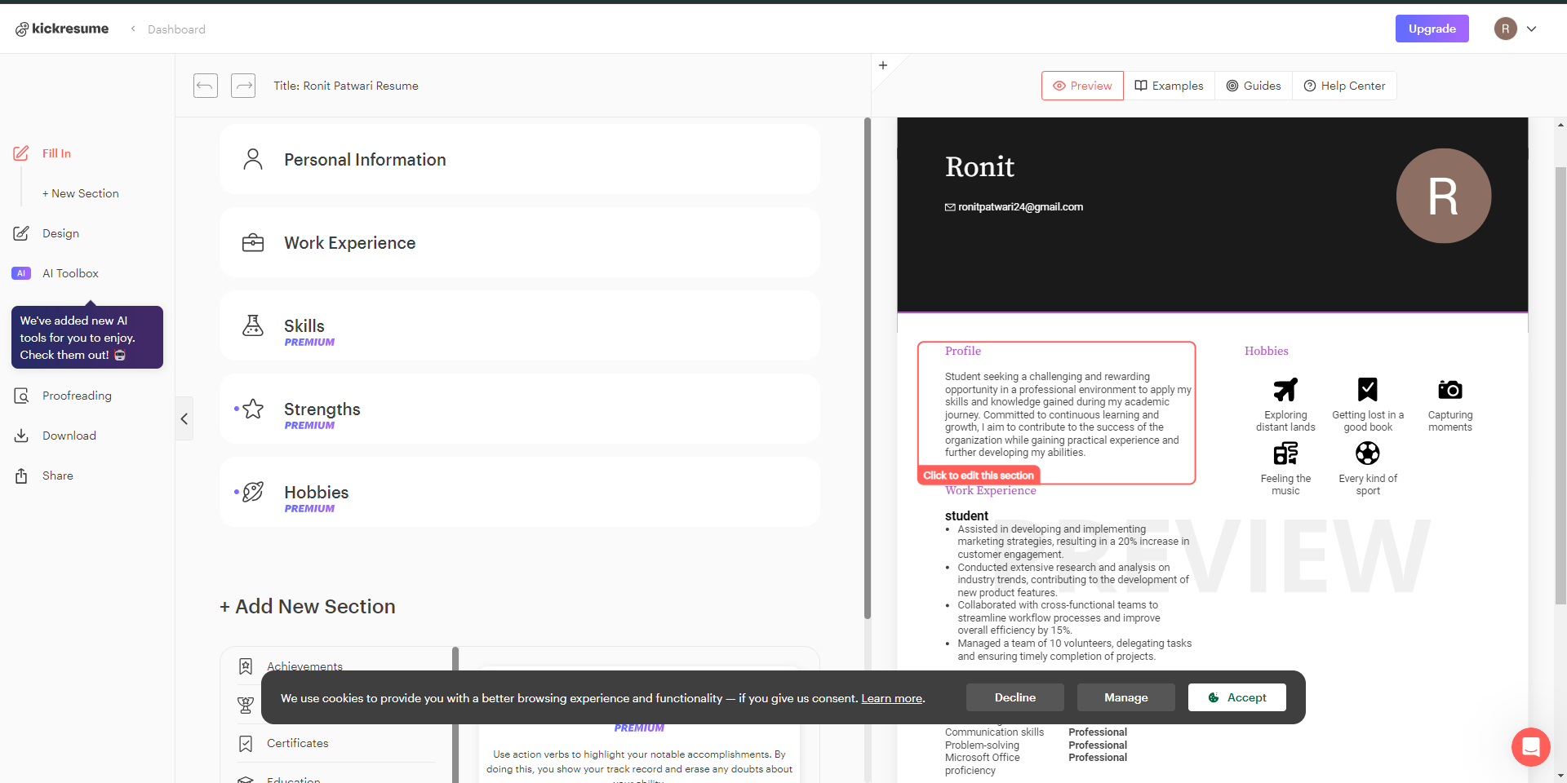

Kick Resume - Kickresume AI is a sophisticated feature of the Kickresume platform that makes use of artificial intelligence to elevate your resume and other job application materials. You can get individualised feedback and suggestions for your resume's structure, format, and presentation using Kickresume AI. Your resume will be optimised for particular job openings and industries thanks to the intelligent tool that analyses it and offers insightful feedback.

Kickresume AI is made to improve your chances of impressing employers and landing the job you want, whether it's by proposing better keywords, improving formatting, or providing suggestions for a more compelling summary. Anyone wishing to produce a standout résumé with the use of AI-driven assistance should use this potent resource.

2)

Lovo-ai- LOVO AI is an advanced TTS technology that transforms written text into lifelike, natural-sounding voice recordings using AI and deep learning methods. These AI-generated voices can be modified and incorporated into a variety of applications, including virtual assistants, customer support services, e-learning platforms, and more.

The technology from LOVO AI has received recognition for its capacity to produce incredibly lifelike and expressive voices, increasing user experiences in a variety of industries. It can be used for voiceovers for podcasts and movies, accessibility services, automated customer care, and more.

3)

Rytr.ai- Rytr is a platform for AI-powered content creation that helps people produce excellent written material quickly and effectively. It generates articles, blog posts, marketing copy, and a variety of other written materials using cutting-edge natural language processing (NLP) algorithms and machine learning. Rytr's AI engine creates logical and contextually appropriate information depending on prompts or input from users.

Rytr is a useful tool for content producers, marketers, and companies looking to speed up and save time on content production. It makes it simple to customise the generated material to meet unique needs and aesthetic preferences by providing a variety of templates. By offering an easy and AI-driven content generation solution, Rytr promises to help users meet their content marketing objectives.

4)

Decktopus- Decktopus is a presentation design tool that makes it easier to make interesting and eye-catching presentations. It provides an intuitive user interface with editable templates, making it simple for people and organisations to create presentations rapidly that appear professional. To improve the effectiveness and quality of presentations, Decktopus also offers features like content recommendations, design components, and collaborative tools.

Decktopus allows users to concentrate on the information and message they want to share while leaving the design and layout to the platform. Professionals, educators, and organisations wishing to develop compelling presentations for conferences, webinars, pitches, and other forms of communication may find this tool very helpful. With the help of Decktopus, users will be able to communicate powerful messages with greater convenience and efficiency during the presentation development process.

5)

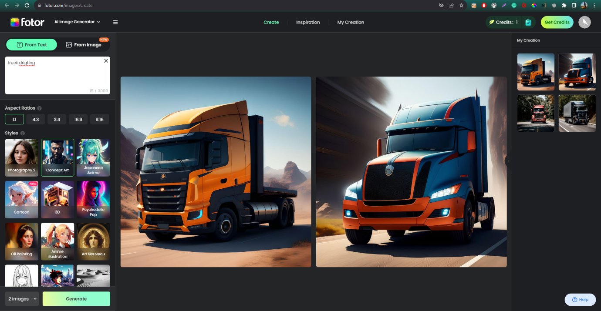

Fotor - Fotor is a well-known and easy-to-use online photo editing and graphic design tool. It includes a plethora of tools and features that enable users to simply edit pictures, create great visual content, and design a variety of materials such as social media posts, banners, brochures, and more.

Fotor's user-friendly interface and numerous templates make it suitable for both novice and experienced designers, making it a versatile and useful tool for anybody wishing to improve their photographs or create eye-catching graphics. Whether you're a social media enthusiast, a professional marketer, or someone who simply wants to improve their images, Fotor has the tools to help you do it swiftly and successfully.